EEE Domain

Functional Analysis

Horned Beast Diagram

Run the drone motor from a power supply

INTRODUCTION

The electric and electronic part is a crucial part pertaining to the control and operation of the drone. The EEE domain makes up a significant part of systems such as propulsion mechanisms, take-off and landing, targeting and weaponry, sensors as well as the computers required to control and co-ordinate an unmanned vehicle’s subsystems.

**Electronic components of the drone**

Battery

Motors

Electronic Speed Controller (Sensors are located there)

Power Distribution Board (PDB)

Flight Controller

RC transmitter and receiver

LED indicators (optional; wanted for our drone)

**Functions of the different systems**

1. Flight Controller (FC)

The flight controller is the brain of the system. It combines the pilot’s input and sensors data to stabilize and move the UAV.

It is a small computer board with sensors like gyroscope, barometer among others.

It receives signals from the transceiver and later on transmit it to the motors and the craft.

It is configured by computer software like Mission planner.

From a hardware point, the FC consists of microcontrollers, sensors and input and output connectors.

1. ESC

The electronic speed controller is used to change the speed and the direction of brushless motors converts DC BATTERY POWER into 3-phase AC for driving brushless motor.

It is the interface between the FC and the motors.

It has 02 specifications, current capacity and input signal.

It comes with a battery eliminator circuit (BEC), which delivers the electric power to other circuitry without the need for multiple batteries.

It offers a high power, high frequency, high resolution 3-phase AC power to the motors to make it fly.

1. Battery

To power on our quadcopter, we will need a Lithium Polymer (LIPO) battery.

Since the flight time of our drone depends on the capacity of the battery, we choose a 2800mah battery

1. RC transmitter and receiver

The radio transmitter is an electronic device that uses radio signals to transmit commands wirelessly via a set radio frequency over to the radio receiver, which is connected to flight controller of the drone being remotely controlled.

Radio transmitters and receivers manipulate electricity resulting in the transmission of useful information through space.

The transmitter sends a signal over a frequency to the receiver.

The transmitter has a power source, that provides the power for the control and transmission of the signal.

Simply, it is a remote controller used to control altitude, speed, the orientation of the drone.

1. Power Distribution Board (PDB)

The PDB essentially distribute power from the battery to the Escs.

We preferred to use a PDB as they reduce the stress on the Flight controllers and are usually better filters for electrical noise

The PDB has tabs marked as S1,S2,S3, S4 indicating the signal tabs for motor 1, 2, 3, 4 respectively.

This is how the FC talks to the ESC and controls how the motor spin.

Function Blok

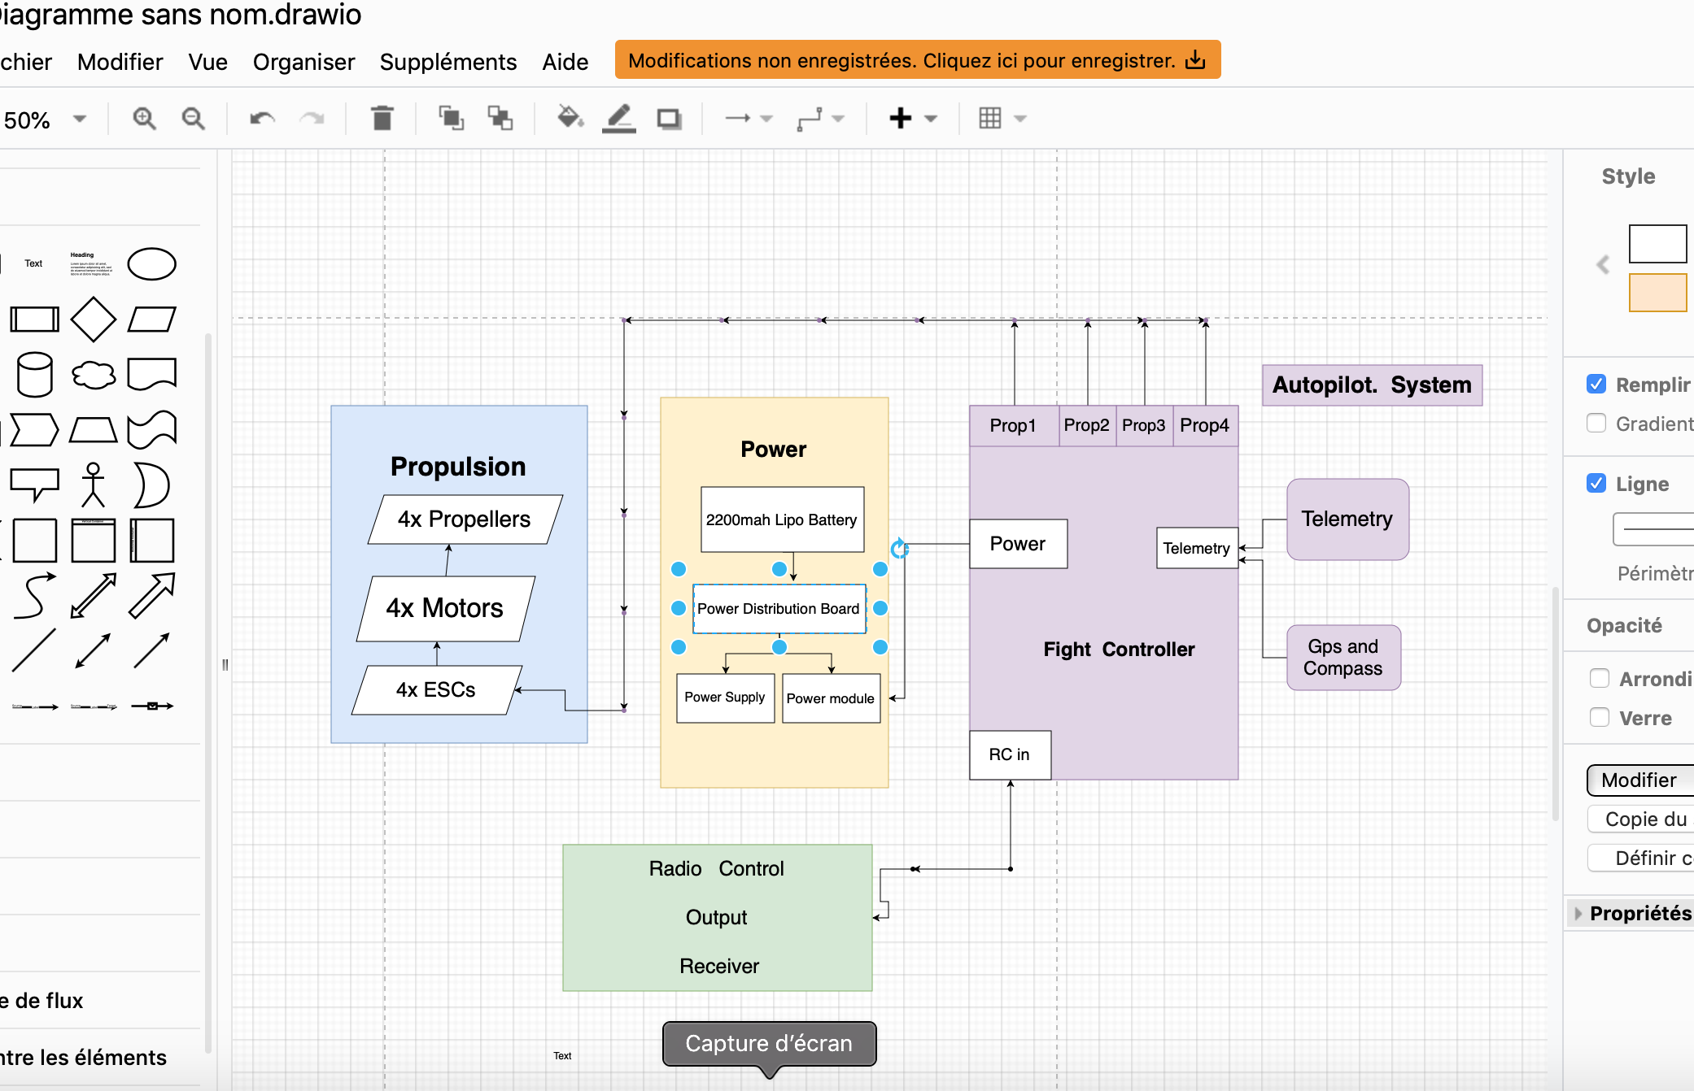

**MOTORS IN OUR DRONE**

There are 2 type of motors used in drones;

-Brushless and Brushed motors.

Characteristics

Brushless motors----------They are way much powerful for their weight than Brushed motors

--------- They last way longer

---------They are the best choice for medium and large quadcopter

Brushed Motors-------------They are fantastic for micro and Nano drones

They are cheaper

Similarities

Their internal workings are same as both are based on electromagnetism

The brushless motor is made up of 2 major parts namely; The stator and the rotor

The stator is the stationary part while the rotor is the rotation part

**Why we choosed Brushless motors**

We decided to choose brushless motors for our drone because they have no brushes rubbing against anything, no energy is lost due to friction. Meaning brushless motors are more energy -efficient than brushed drills and can run up batteries up to 50% longer.

**Autonomy Calculation**

Time(h)= Capacity (Ah) / Current(A)

C=2200mah

I=2.2A

t =2200/2.2

=1h

P=IV

I=2.2A , V=11.1V

P= 2.2 x 11.1

=24.42W

.

**Sensors in our drone**

Despite the numerous sensors which will be present in our to be drone, they are some which are primordial;

1. **Inertial Measurement Units (IMUs)**

They fuse together information from different sensors to provide measurements that can be used to calculate orientation, pressure altimeter and velocity of the UAV.

-Accelerometer; It determines the linear movement along any axis

-Gyroscope; It determines the rate of rotation or angular velocity and tilt.

-Magnetometer; It indicates the direction of the magnetic field to verify heading

1. **GPS/GNS**

SIgnals for above-ground applications can provide more precise location information. Check out our GPS/INS Blog to reach more about how drones navigate and maneuveur around diificult to reach locations.

**Conclusion**

Finally, we are Now capable of identifying the different electronic part of the drone, select the best type of motors for the different type of drones as much as their batteries, and find the adequate sensors.